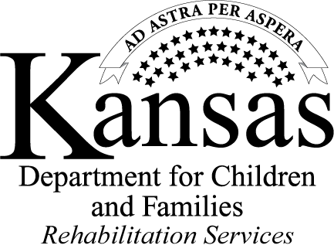
Pre-Employment Transition Services
The bridge to your employment future

Empowering youth with disabilities to achieve their highest employment potential is one of the major goals of Rehabilitation Services (RS). To help achieve this goal, RS is providing Pre-Employment Transition Services (Pre-ETS), which were authorized by the Workforce Innovation and Opportunity Act. Pre-ETS are designed to provide job exploration, counseling and other services to help young people prepare for employment and self-reliance, rather than dependency on public benefits.
In collaboration with local education agencies and qualified community partners, RS will provide or arrange for the provision of Pre-Employment Transition Services for students with disabilities who are in need of such services and who meet the following participation criteria:

- The student is 16-21 years of age.

- The student is in a secondary, post-secondary, or other recognized education program.

- The student is eligible for, and receiving services under an Individual Education Plan or 504 Plan, or the student is an individual with a disability as defined by Section 504 of the Rehabilitation Act.

- The student is a resident of Kansas. Any student with a disability who is not a U.S. citizen must have employment authorization documentation.

Services are designed to be an early start at job exploration and to assist students with disabilities in making the transition from secondary to post-secondary education/training and competitive integrated employment.

Continued on the next page

JOB EXPLORATION COUNSELING
Provides students with disabilities the opportunity to explore how their skills
and interests match with jobs available in the labor market.
- Administer vocational interest inventories.  - Review labor market information. | - Explore jobs/careers in the community.  - Connect the student to other resources in the community.

SELF ADVOCACY
Empowers students with disabilities to express their needs
and goals in a variety of settings such as school and work.
- Help students learn their rights and responsibilities under the Individuals with Disabilites Education Act and Section 504 of the Rehabilitation Act.  - Identify self-advocacy skills and why they are important. | - Help the student build their own advocacy skills.  - Connect students to other resources in the community.  - Help students learn to request accommodations or services and supports.

WORKPLACE READINESS TRAINING
Supplies students with disabilities with the opportunity to learn power skills necessary for success on the job,
such as customer service, how to interact with co-workers, supervisors, being on time, etc.
- Connect students with local career centers.  - Identify social and independent living skills. | - Identify and discuss employability skills.  - Connect students to other resources in the community.

COUNSELING ON COMPREHENSIVE TRANSITION
OR POST-SECONDARY EDUCATION
Provides a clear path to an employment future for students with disabilities.
- Provide information to connect students to education opportunities including disability support services.  - Discuss reasonable accommodations for success in training and academic settings. | - Educate and inform students about post-secondary training programs.  - Connect students to other resources in the community.

WORK-BASED LEARNING EXPERIENCES
Provides work-based learning experiences where youth can learn the skills
necessary to succeed in the workplace and experience the benefits of earned income.
- Facilitate job shadowing and/or mock interviews.  - Connect students to career track and/or other work-based learning programs. | - Identify local businesses for work-based learning experience opportunities.

For referral to the Pre-ETS Transition Specialist serving your community, please call the Rehabilitation Services toll-free Customer Service Line: 1-866-213-9079.

