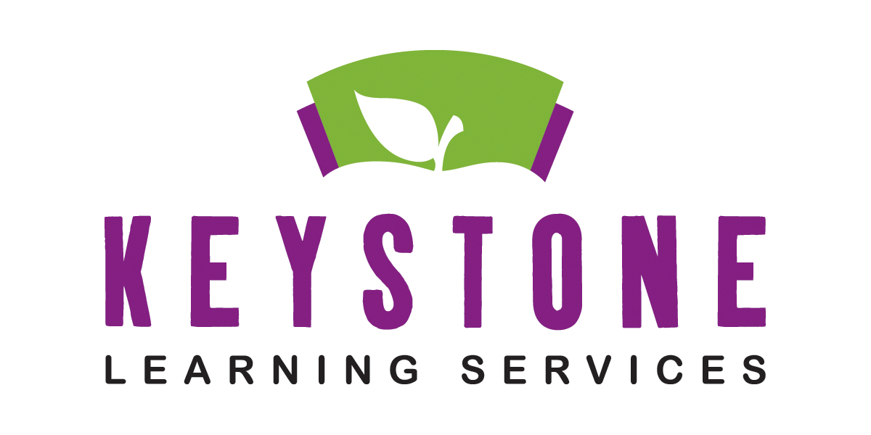

Para Staff Development Documentation

Name:____________________________________________

Date of Staff Development:_____________________ Training Site:_________________________________________

Presenter:______________________________________________ Number of Hours:_______________

Staff Development Topic:_________________________________________________________________________________

Video:__________________________________ Reading(# of pages):_____________________________

Description of Staff Development Activity:

____________________________________________ _________________________________________
Para Signature Supervisor’s Signature

Please return to Melody Malone at the Keystone Learning Services Office

Approved:____________

Denied:_______________

____________________________________________
Administrator

