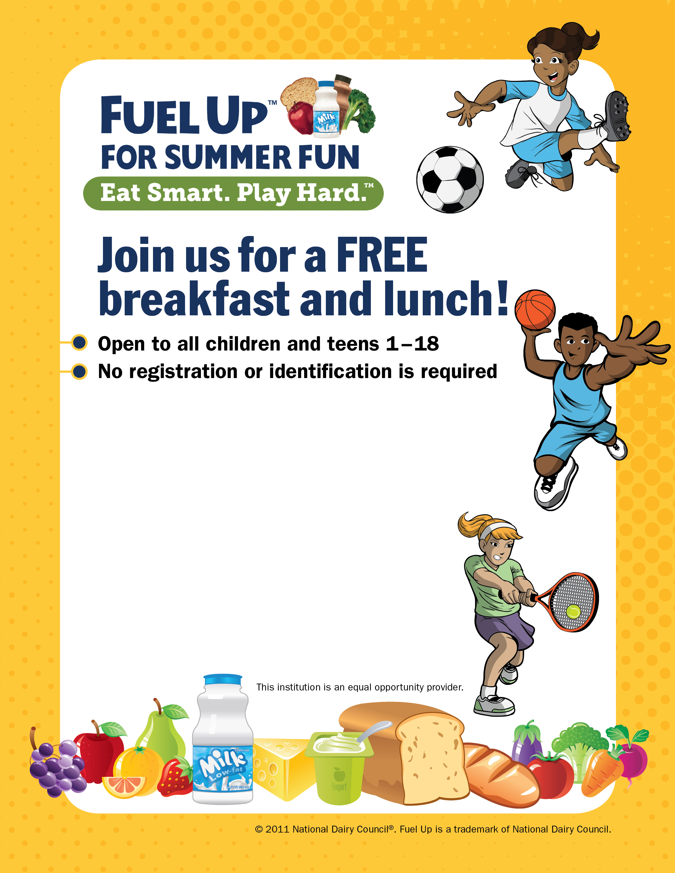
Dates: June 4, 2018 through July 26, 2018
Monday through Thursday ONLY, Closed on Fridays

Time: Breakfast at 8:30 a.m.
Lunch at 11:30 a.m.

Location: Keystone Learning Services
500 E. Sunflower Blvd.
Ozawkie, KS 66070

Contact: Lisa Morando, 785-876-2214

