Top of Form

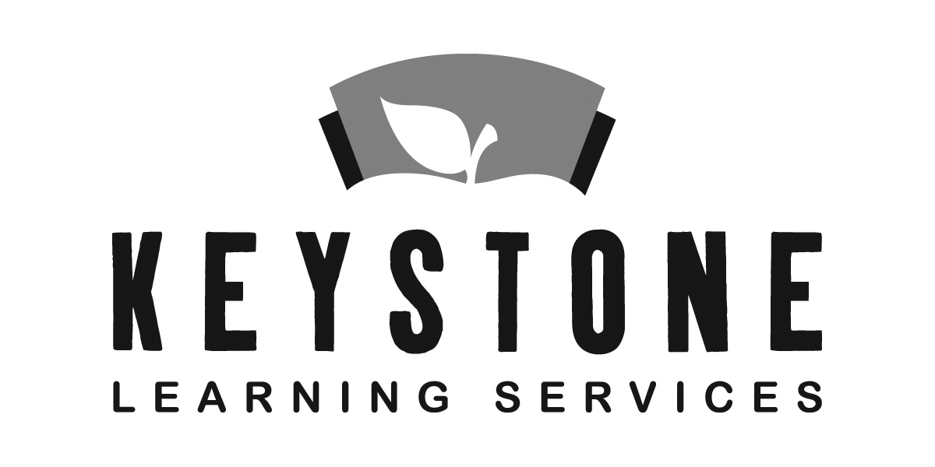

For Office Use
Date Received__________
Age 9/1/19____Y____M___D__
CYKI appt._______________
Parent Called____________
Wait List #______________
Notes

Bottom of Form

NORTHEAST KANSAS EDUCATION SERVICE CENTER
500 E. Sunflower Blvd., Ozawkie, KS 66070
785-876-2214 ext. 201
Fax – 785-876-2383

PEER MODEL APPLICATION FORM

EARLY CHILDHOOD SPECIAL EDUCATION CLASS

Please check the boxes below, and sign, to acknowledge that you have read the following.
Peer models will be selected by a random drawing from the applicants for each school year.

Peer models must be potty trained. All children attending the preschool must have proof of immunizations and the child health assessment required by the state of Kansas. Peer models must reside in one of the eight school districts participating in the Keystone special education cooperative or a hosting district employs their parents.

Parents of peer model students are responsible for transporting their child to and from the classroom.

I have read the above _________________________________________________________
Parent Signature

Preference will be given to children who are 4 years old by September 1st, but 3 year olds will be considered. Children turning 5 prior to Sept. 1st are considered kindergarten eligible and are not eligible for Keystone preschool programs. Children selected, as peer model candidates need to participate in a Count Your Kid In screening by June 28, 2019. The purpose of this screening is to verify that the child is not experiencing developmental delays. An appointment for the Count Your Kid In screenings can be made by contacting Lesa Brose at the Keystone phone number listed above. Please specify that you are interested in the peer model program.

Child’s name M F Date of birth
(Circle one)

Parent name School District

Address Phone #

City Zip Phone #

Today’s Date E-mail

Keystone Learning Services does not discriminate on the basis of race, color, national origin, sex, disability, or age in its programs and activities. The following person has been designated to handle inquiries regarding the non-discrimination policies: Executive Director, Keystone Learning Services, 500 E. Sunflower Blvd.; Ozawkie, KS 66070, 785-876-2214.

Revised 8/28/2018

