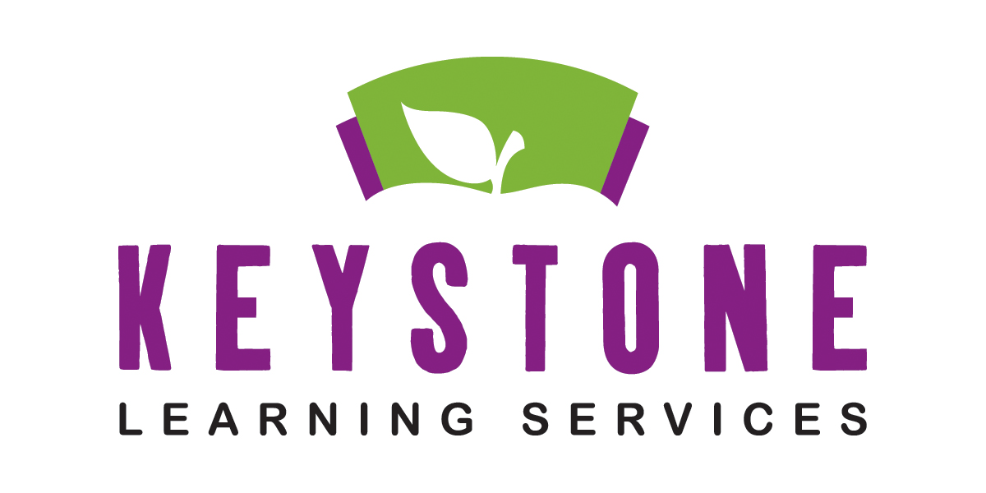

**Peer Model Application Information**

**Please complete the Peer Model application and return to the following address:**

Keystone Learning Services

c/o Lesa Brose

500 E. Sunflower Blvd.

Ozawkie, KS 66070

Applications need to be **returned by** **June 26, 2020**. The drawing takes place in **July of 2020**.

Parents will be notified with the outcome of the draw.

**Please keep this letter as a reminder of the following requirements:**

* Peer models are selected by a **random** drawing
* The ECSE programs are Monday through Thursday and meet in half-day sessions.
* Parents of peer model students are responsible for their child’s transportation to and from the school.
* 4 year olds are given first priority
* Peer models must be potty trained
* Children turning 5 prior to Sept. 1 are considered kindergarten eligible and are not eligible for Keystone preschool programs.
* All children attending the preschool must have proof of immunizations and the child health assessment required by the state of Kansas.
* **Peer models must** **reside** in one of the eight school districts participating in the Keystone special education cooperative or **has a parent that is employed by a hosting district**.
* Due to limited preschools in this area, please consider only enrolling your child in one pre-school experience each year.
* Peer models MUST attend a CYKI screening by **June 26, 2020** to verify that the child is not experiencing any developmental delays. An appointment can be set up by contacting, Lesa Brose, at 785-876-2214 ext. 201. **Please specify that you are interested in the peer model program.**

Questions may be directed to Lesa Brose at 785-876-2214 ext. 201 or email to lbrose@keystonelearning.org

***Parents As Teachers/tiny k/Technology Services/John Dewey Learning Academy/Operations and Facilities***

***Special Education/WebKIDSS/Grant Management***

500 Sunflower Blvd. Ozawkie, KS 66070 T 785-876-2214 F 785-876-2383 www.keystonelearning.org

Enlighten, Empower!