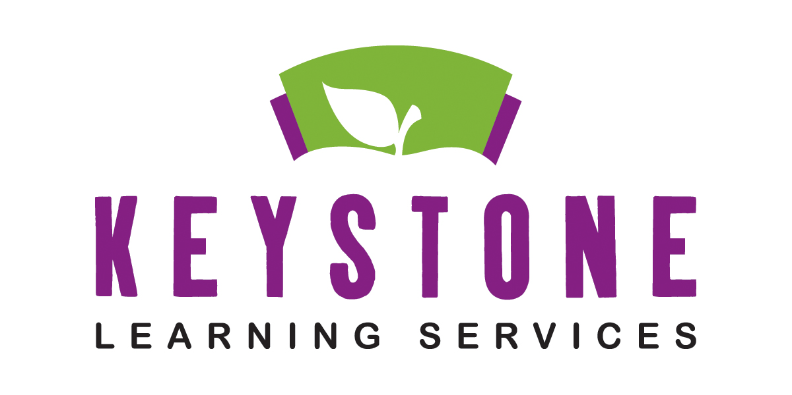

May 26, 2020

Keystone Learning Family,

As you are all aware, we will be resuming services to our students this summer starting June 1, 2020. As a result, we thought it would be best to send out quick memo about what we can look forward to and what we can expect during this time. First and foremost, Keystone Learning Services takes your health and well-being very seriously. Rest assured, we will be acting within the restrictions of the State of Kansas and our local health agencies to limit the potential exposure of staff and students to COVID-19. With that, we hope that all our staff and students/families will do their part to help reduce that risk as well. Proper hygiene, social-distancing, and other safety measure should be employed and observed by everyone to help prevent potential exposure to the virus.

While Keystone will do its part to reduce the risk of exposure, we realize that whenever there is interaction between people, there is the potential for exposure. We count on everyone involved to do their part in helping reduce this risk further. We hope that together, we can carry on with a successful and fulfilling education experience this summer and into the fall with your help.

Stay healthy and safe.

Keystone Learning Services Staff

***Parents As Teachers/tiny k/Technology Services/John Dewey Learning Academy/Operations and Facilities***

***Special Education/WebKIDSS/Grant Management***

500 Sunflower Blvd. Ozawkie, KS 66070 T 785-876-2214 F 785-876-2629 www.keystonelearning.org

Enlighten, Empower!