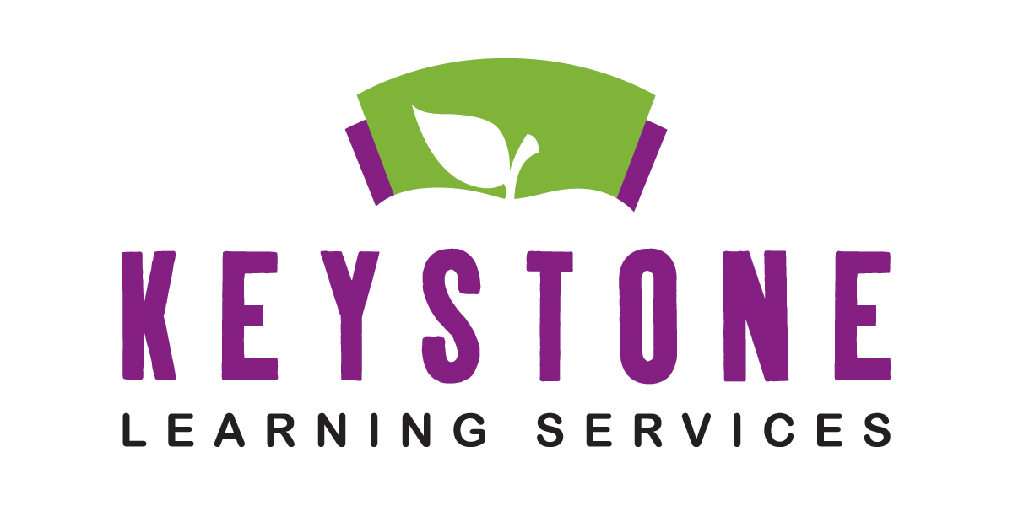

Early Childhood Special Education Peer Model Program Information
(Parents Please Keep This for Your Reference)

The ECSE classrooms are designed for children 3 to 5 years of age who qualify for services in areas such as communicating, learning, vision, moving, or socializing. To enhance the program, children who are developing typically are accepted as peer models. The ECSE classrooms are located at the following locations – Meriden, Oskaloosa, and Valley Falls.

Guidelines for selecting peer models for ECSE classrooms:
- Peer models must reside in one of the eight school districts served by Keystone or have a parent that is employed by a hosting district. These districts are Perry Lecompton USD #343, Jefferson West USD #340, Oskaloosa USD #341, McLouth USD #342, Jefferson County North USD #339, Valley Falls USD #338, Atchison County USD #377 and Easton USD #449.
- It is preferred that peer models be 4 years old on or before September 1. However, 3-year-olds will be considered. Children must be potty trained. Children turning 5 prior to September 1 are considered kindergarten eligible and are not eligible for Keystone preschool programs.
- Children chosen for peer model positions will need to be screened at a Count Your Kid In screening which needs to be done by June 30, 2022. The purpose of this screening is to verify that the child is not experiencing any developmental delays.
- An appointment for a Count Your Kid In screening can be made by contacting Lesa Brose at either of the contacts listed below. Please let her know that you are interested in the peer model program.

Additional requirements:
- Peer models are selected by a random drawing in July of 2022 for the following school year. A waiting list will be compiled from names that were not drawn.
- The ECSE programs are Monday through Thursday for Oskaloosa and Jefferson West, Tuesday through Friday at Valley Falls, and meet in half-day sessions at all locations. The classroom teacher will assign the session that the peer model attends.
- Parents of peer model students are responsible for their child’s transportation to and from the school.
- All children attending the preschool must have proof of immunizations and the child health assessment required by the state of Kansas.
- Due to limited preschools in this area, please consider only enrolling your child in one pre-school experience each year.

For questions or to make a CYKI screening appointment, please contact:
Lesa Brose at phone number 785-876-2214 ext. 201 or lbrose@keystonelearning.org.

Keystone Learning Services does not discriminate on the basis of race, color, national origin, sex, disability, or age in its programs and activities. The following person has been designated to handle inquiries regarding the non-discrimination policies: Executive Director, Keystone Learning Services, 503 Sunflower, Ozawkie, KS 66070, 785-876-2214.

Revised 8/12/2021

