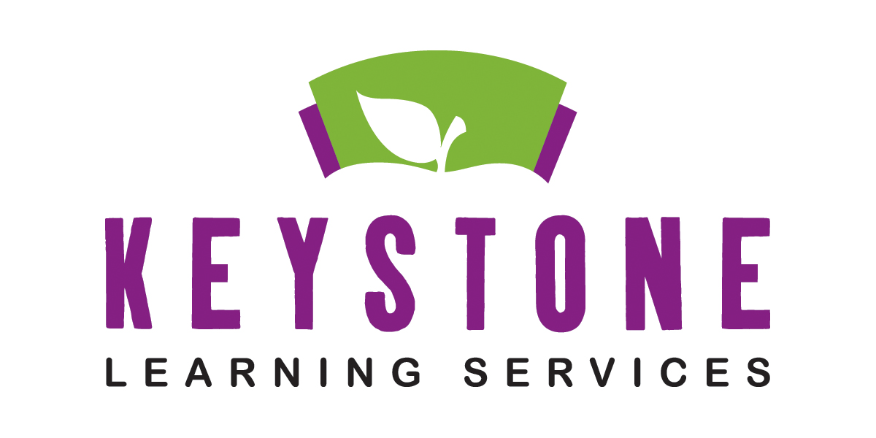

COUNT YOUR KID IN
Screening Schedule 2023-2024

FREE INFANT AND PRESCHOOL SCREENING CLINIC

WHO: Keystone Learning Services and the Jefferson County Health Department

WHAT: Count Your Kid In: If you have concerns about your child’s development, this free screening will provide help for children 0-5 years of age. Children are screened in areas of speech/language development, motor development, concept development, social skills, vision and hearing.

CALL- (785) 876-2214 EXT. 201 for a screening appointment at any of the following locations

August 18, 2023- TBD (If needed with summer call ins)

September 29, 2023- Oskaloosa City Hall 212 W. Washington St.

October 27, 2023- Perry/Methodist Church 220 Oak St.

November 17, 2023- Meriden/Jeffwest Grade School 301 Main St.

December 1, 2023- Valley Falls/VF Christian Church 511 Oak St.

January 19, 2024- Effingham/St. Ann’s Activity Center 301 Williams St.

February 23, 2024- McLouth/Church of the Nazarene 901 Eat Lake St.

March 22, 2024- Nortonville/Christian Church 19861 Osage Rd

April (TBD), 2024- Easton/Pleasant Ridge Elem. 20753 Easton Rd

May 10, 2024- Lecompton/Lecompton United Methodist Church

