Emergency Safety Intervention
Parent Information

If an emergency safety intervention was used with a student, we invite and strongly encourage parents to schedule a meeting to discuss the incident and how to prevent future use of emergency safety interventions. A parent can request and schedule this meeting by going to the back page for the person to contact who will work to schedule this meeting with the required participants. This meeting will be scheduled no later than 10-school days from when the parent makes the request unless the parent cannot meet within that time frame.

John Dewey Learning Academy
http://www.keystonelearning.org/ESI.html Terri Coughlin, Principal
785-876-2214
coughlint@keystonelearning.org
Table of Contents

Standards of When ESI May Be Used …………………………….………….……. Page 3
Parents’ Rights Flyer …………………………………………………….………………… Page 5
Local Dispute Resolution Process ………………………………….……………….. Page 11
Local Dispute Resolution Guide for Parents ………………..…………………. Page 12
State Board Administrative Review Process …………………………………… Page 13
State Board Administrative Review Guide for Parents …………………..… Page 15
Contact Information ………………………………………………………………………… Page 16

Standards of When Emergency Safety Intervention May Be Used
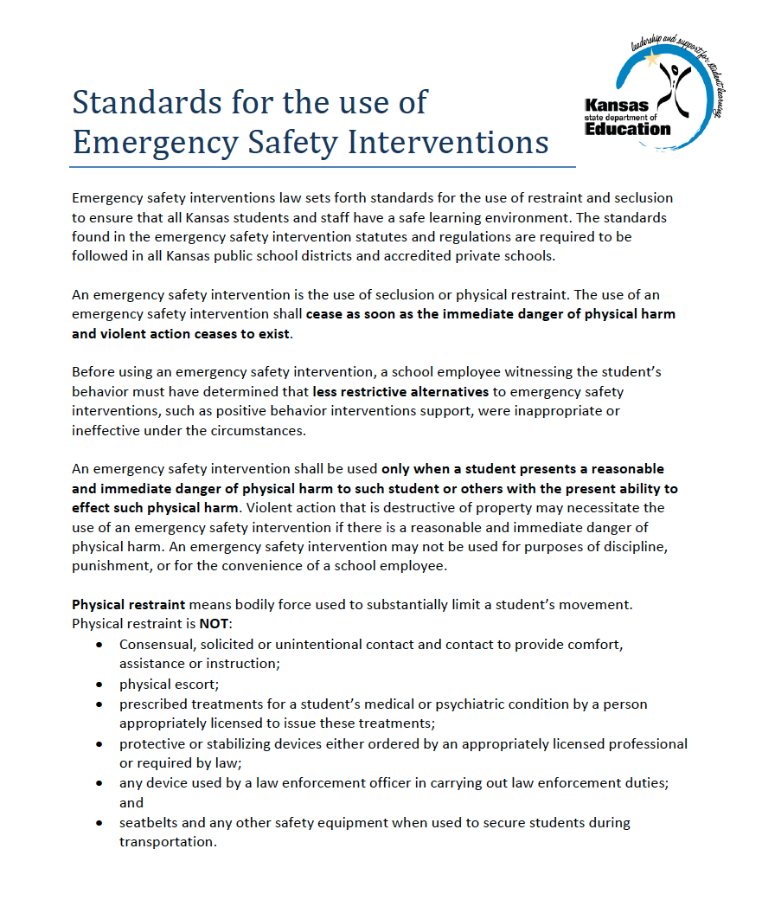

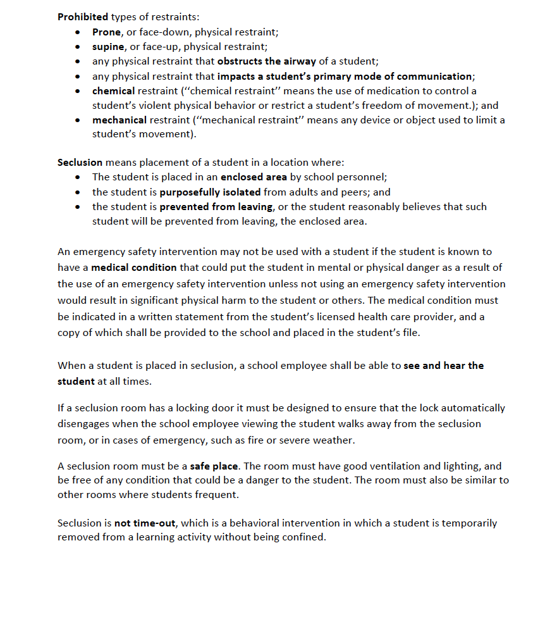

Parents’ Rights Flyer
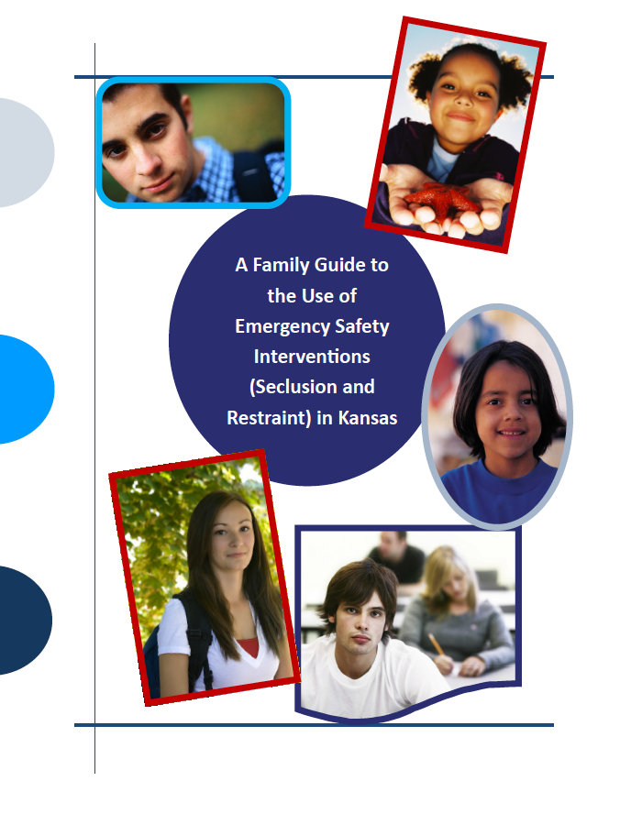
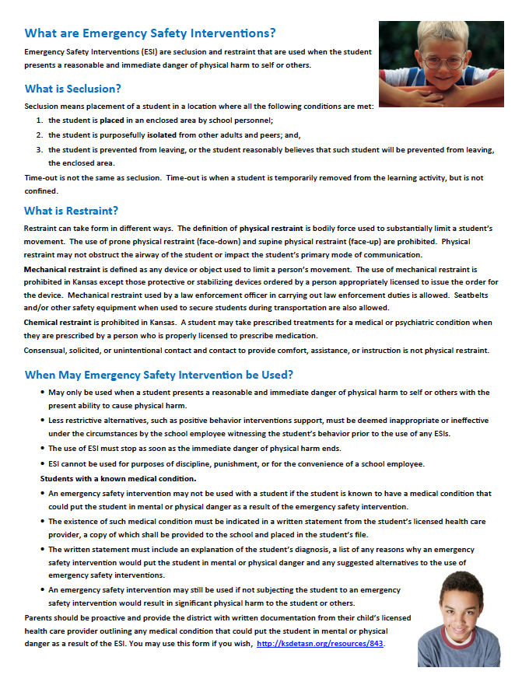
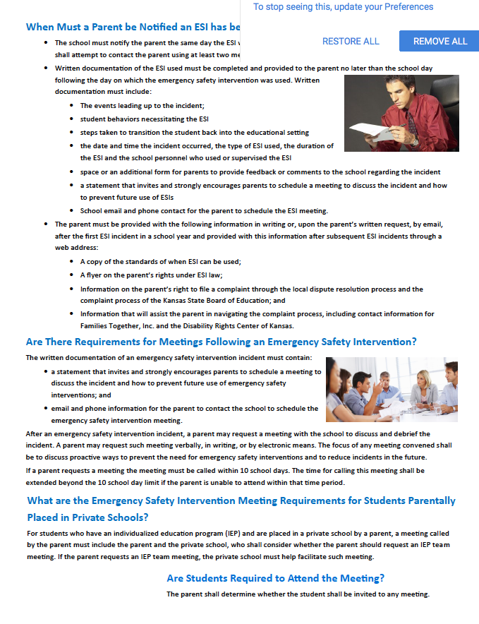

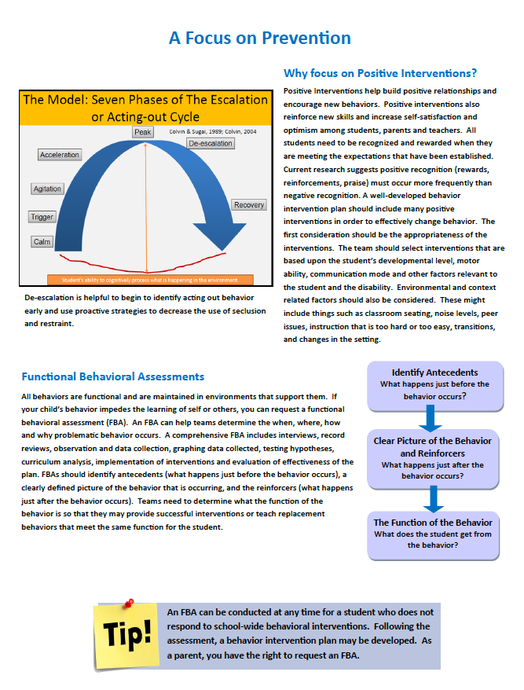

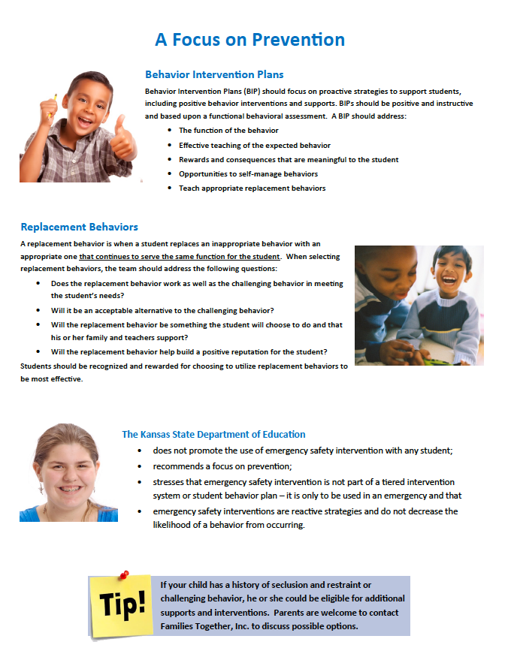

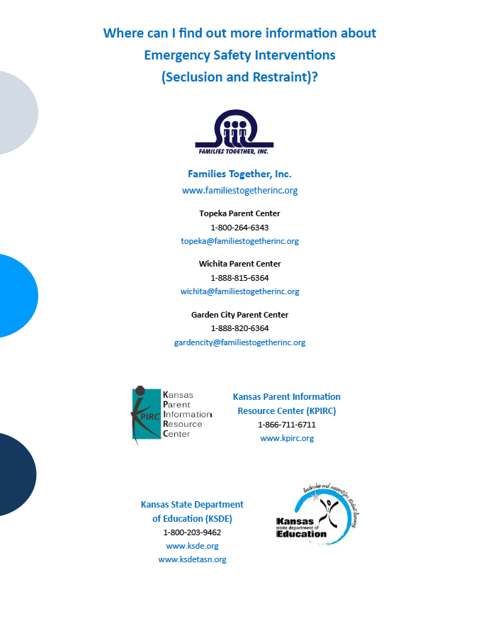
Local Dispute Resolution Process

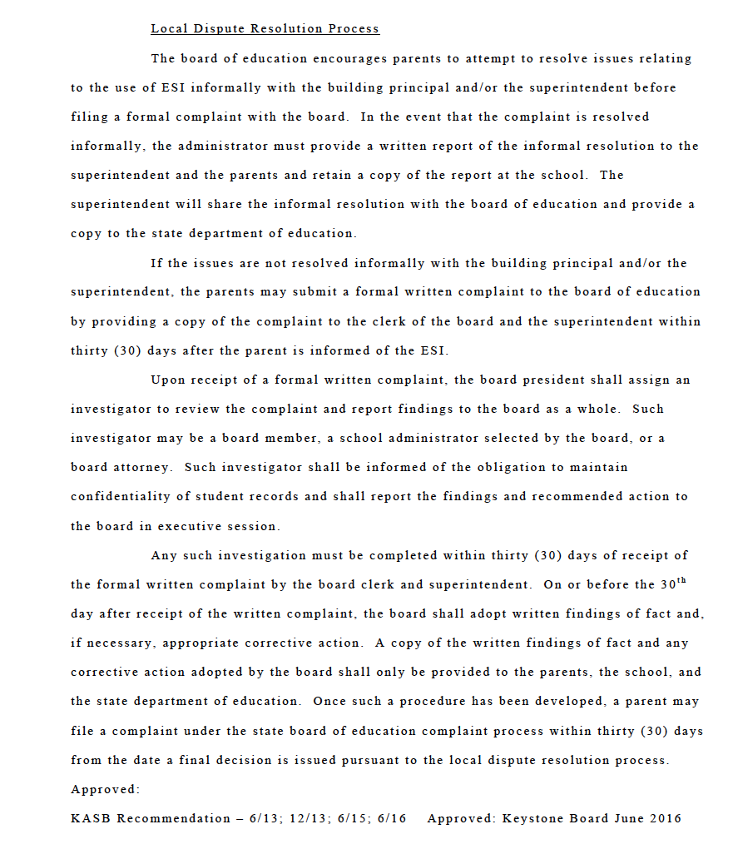
Local Dispute Resolution Guide for Parents

State Board Administrative Review Process

Refer to K.A.R. 91-42-5 for complete information. The following provides a summary of the regulations regarding an administrative review initiated with the Kansas State Board of Education (State Board).

- If a parent believes an emergency safety intervention was used in violation of K.S.A. 2016 Supp. 72‐89d01 through -89d09 or K.A.R. 91-42-1 through -7 and the parent filed a written complaint with their local board of education, then this parent may request an administrative review of the local board’s decision from the State Board.
  - The request for administrative review must include the following information:
    - Name of the student and contact information;
    - Names and contact information for all involved parties (teachers, aides, administrators, and district staff), to the extent known;
    - A detailed statement of the reason for requesting an administrative review;
    - Any supporting facts and documentation; and
    - A copy of the complaint filed with the local board, the local board’s final decision (if issued).
    - The written request for administrative review must be typed or legibly written and signed by the parent.
    - Relevant documents must be attached or, if unavailable, the documents must be referenced in the request for administrative review.
    - Written consent to disclose any personally identifiable information from the student’s education records necessary to conduct an investigation

- The request for administrative review must be filed with the Commissioner of Education within 30 days of the local board issuing its final decision OR within 60 days from the date the parent filed a complaint with the local board, if the local board did not issue a final decision. You may mail this request to the Kansas State Department of Education, Landon State Office Building, 900 SW Jackson Street, Office of General Counsel, Room 102, Topeka, Kansas 66612. KSDE has provided a form for you to use, if you wish, and you can find it on the Emergency Safety Interventions page of the KSDE website, www.ksde.org/Default.aspx?tabid=524.

- A Hearing Officer will be designated by the State Board. The Hearing Officer must send a copy of the request for administrative review to the local board.

- The Hearing Officer will consider the local board’s final decision and may initiate an investigation that could include:
  - A discussion with the parent, during which additional information may be gathered;
  - Contact with the local board or other district staff to allow the local board to respond to the request with information supporting its final decision; and
  - An on-site investigation by Kansas State Department of Education staff.

- If new information is discovered that was not made available to both the parent and the local board during the dispute resolution process, the Hearing Officer may send the issue back to the local board.
  - If sent back to the local board, the Hearing Officer’s case will be closed and the local board has 30 days to issue a written amended final decision.
  - If the parent feels the local board’s amended final decision does not adequately address the issue, the parent may file a new request for administrative review with the commissioner by following the above process for requesting administrative review. This must be done within 30 days of the local board issuing its amended final decision. If the local board does not issue an amended final decision within 30 days, then the parent has 30 days from the date the Hearing Officer sent the issue back to the local board to file a request for administrative review with the commissioner.

- Within 60 days of receiving the request for administrative review, the Hearing Officer will, in writing, inform the parents, school administrator, district superintendent, local board clerk, and the state board of the results of the review. This time frame may be extended for good cause upon approval of the commissioner.

- The results of the administrative review will contain findings of fact, conclusions of law, and any suggested corrective actions. The Hearing Officer’s determination will include one of the following:

  - The local board appropriately resolved the complaint.
  - The local board should re-evaluate the complaint with suggested findings of fact.
  - The Hearing Officer’s suggested corrective active is necessary to ensure that local board policies meet legal requirements.

State Administrative Review Guide for Parents
Written request must include:
- Name and contact information of student that emergency safety intervention was used with
- Name and contact information for all people involved
- Statement describing the basis for the review with all supporting facts and documentation
- The local board’s final decision, if one was issued
- Type or legibly write the complaint and sign it
- Written consent to disclose any personally identifiable information
You may use the form on the KSDE website, www.ksde.org/Default.aspx?tabid=524.
Mail this request to the Emergency Safety Intervention Administrative Review Request, Kansas State Department of Education, Office of General Counsel, 900 SW Jackson Street, Room 102, Topeka, Kansas 66612
The Hearing Officer may initiate a separate investigation that may include:
- A discussion with the parent;
- Contacting the local board or other staff involved; and
- An on-site investigation.

If the Hearing Officer finds new information, they may send the issue back to the local board. If you are not satisfied with the local board’s amended decision the right to request administrative review begins again.
A request for an administrative review may include, but is not limited to, the following allegations:
- An emergency safety intervention was used with your child when your child did not present a reasonable and immediate danger of physical harm to themselves or others with the present ability to effect such physical harm.
- The district used a form of banned restraint including prone, supine, physical restraint that obstructs the airway of your child, physical restraint that impacts your child’s primary mode of communication, chemical or mechanical restraint that does not meet an exception.
- Less restrictive alternatives to emergency safety intervention were not deemed inappropriate or ineffective before emergency safety intervention was used.
- The use of emergency safety intervention with your child did not stop as soon as the immediate danger of physical harm stopped.
- emergency safety intervention was used with your child for discipline, punishment, or convenience.
- Emergency safety intervention was used with your child and you have provided school staff with documentation from your child’s licensed health care provider that seclusion could put your child in mental or physical danger.
- Seclusion was used with your child and school staff could not see and hear your child at all times.
- Your child was put in a seclusion room with a locking door that does not automatically disengage when school staff walk away or in an emergency.
- Your child was put in a seclusion room that was unsafe, not well-ventilated, or not sufficiently lighted.

Contact Information

Local

District Administrator Contact for Emergency Safety Intervention Questions
Andy Ewing
785-876-2214
aewing@keystonelearning.org

School Administrator Contact for Emergency Safety Intervention Questions or to Schedule a Meeting to Discuss the Use of Emergency Safety Intervention
Terri Coughlin
785-876-2214
coughlint@keystonelearning.org

http://www.keystonelearning.org/ESI.html

State

General Emergency Safety Intervention Information:
www.ksdetasn.org
www.ksde.org/Default.aspx?tabid=524

Emergency Safety Intervention Questions:
Laura Jurgensen or Julie Ehler
Kansas State Department of Education
ljurgensen@ksde.org or jehler@ksde.org
785-296-5522 or 785-296-1944

Parent Training and Information Center:
Families Together
http://familiestogetherinc.org/
888-815-6364

Protection and Advocacy System:
Disability Rights Center of Kansas
http://www.drckansas.org/
877-776-1541 or 785-273-9661

