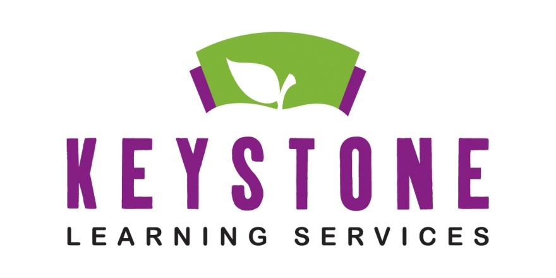
Keystone Learning Services

OPERATIONS AND FACILITIES

Paul Crawford, Director

500 E. Sunflower Blvd.
Ozawkie, KS 66070

785-409-9829 –Paul’s Cell
785-876-2214 – Office
785-876-2383 – Fax

Operations and Facilities Professional Services
Energy Audits…Asbestos Re-Inspections and Surveillance…Attendance Center Tornado Assessments…Custodial-Maintenance Building Reviews…Support Buildings…Classroom and Restroom Upgrades…Specifications for Sports Lighting…Parking Lot and Concrete Projects…Custodial-Maintenance Training….

OTHER PROFESSIONAL SERVICES...

Building Plans and Specifications Designed by David Griffin, Registered Architect and KU Professor Emeritus

Support Buildings
- Locker Rooms and Weight Training Facilities
- All Types of Maintenance Structures
- Concession and Storage Facilities
- Building Remodels and Additions

Classroom and Restroom Upgrades

- ADA Checks

Specifications for Sports Needs & Lighting

- Tennis Courts
- Football Fields
- Soccer Fields
- Baseball & Softball Fields

Parking Lot and Concrete Projects

Custodial-Maintenance Training

Asbestos Awareness
Worker Right to Know
Blood Borne Pathogens
Back Safety for School Employees
MRSA Awareness
School Fire Safety
Maintenance Lock-Out /Tag-Out
Fork Lift Training
Hazardous Spills
Lead Training
Annual Training Requirements for the State of Kansas

Energy Audits
- What can be done to save dollars?
Asbestos Re-Inspections and Surveillance
- Over 30 years experience in asbestos management and inspection
- Experience in over 12 Kansas school districts
Attendance Center Tornado Assessments
- Using KSDE approved Tornado Assessments
- Comprehensive report and recommendations for each building
Custodial-Maintenance Building Reviews
- How does your building and staff stack up?
- What long-term and short-term needs should be addressed?
- Facility & building life span reviews

